
phgy312
lecture #: | date: | professor:
35 | April 4, 2007 | Dr. Mortola
36 | April 11, 2007 | Dr. Mortola
announcements:
- Good luck on exams!!

Edited By: Aradhana Persad and Tiffany Chan
Do Not Redistribute
set #12
PHGY 312 – Lecture 35 April 4th, 2007
Writer: Roni Wisehart Dr. Mortola

RESPIRATORY PHYSIOLOGY – ENERGY COSTS

I. REVIEW FROM LAST LECTURE
- How chronic hypoxia affects different functions
- Acclimatization to hypoxia
- Mechanism of ventilatory acclimatization
  - Central chemoreceptors: participate because of re-acidification
    - Triggered by pH only
  - Peripheral chemoreceptors: become progressively more sensitized, and increase their activity at a given PO₂
    - Triggered by PO₂ and pH
  - CO₂ diffusion is faster than bicarbonate diffusion, so at the beginning of hypoxia there is an alkalosis
    - Over time, there is compensation of alkalosis, which participates in ventilatory acclimatization
  - Ventilatory desensitization is something we don’t know a lot about, but it may mirror acclimatization
- Hypoxia in the prenatal period
  - Causes hypometabolism (a decrease in metabolic rate), which can be the difference between life and death
- This occurs in all large mammals
- As a result, growth is given up, in addition to other things, such as thermal regulation, to save energy
  - Causes a re-acidification of the arterial blood
  - Increases lung compliance: this takes a long time and is not present in humans as much as it is in other animals
- Some highlanders for example have very high lung compliance, and they hyperventilate at rest, although this is minor because they do not as much as we would in their conditions
- When challenged with hypoxia again they respond less (blunted ventilatory response)
- They also have high hematocrit and a high concentration of hemoglobin

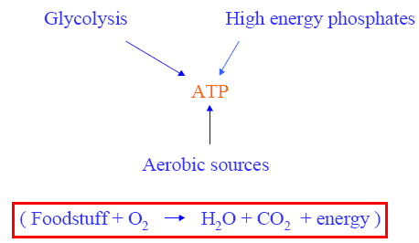
II. METBOLISM DURING EXERCISE
- ATP is the currency for what happens in the body, including muscle contraction
- We don’t have a lot of ATP, so it needs to be replenished
  - This is done anaerobically (glycolitically) and although it is long-lasting, high capacitance mechanism, it is inefficient
  - Very few ATPs are created per molecule of glucose, and lactic acid is produced, which is toxic for your body
  - Therefore, we rely mainly on aerobic sources (oxygen)
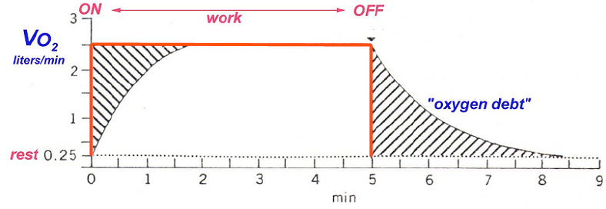
- In the graph, at time = 0, there is an instantaneous contraction
- You can’t count on O₂ right away, because it lags behind the response
- Therefore, you must count on anaerobic ATP to do the initial work, so that you don’t have to wait until cardiac output goes up and increases ventilation to do this work
- You rely on anaerobic sources initially because O₂ lags behind but it will eventually catch up
  - Note that on the graph O₂ consumption (VO₂ ) = Energy
  - The first shaded area corresponds to the energy borrowed until O₂ consumption is at the level you want. The energy borrowed is ATP
- Eventually, you must pay back what was borrowed, so when the work stops, you don’t stop consuming O_{2.} This is called “payment of oxygen debt”
- Theoretically, the 2 shaded areas should be the same but in reality the 1st area is bigger because of the increase in metabolic rate during the workload
  - For our purposes we can assume they are the same; what we take is what we give back

III. OXYGEN COMSUMPTION AND POWER
- If exercise is more vigorous, the oxygen consumption level will settle at higher value
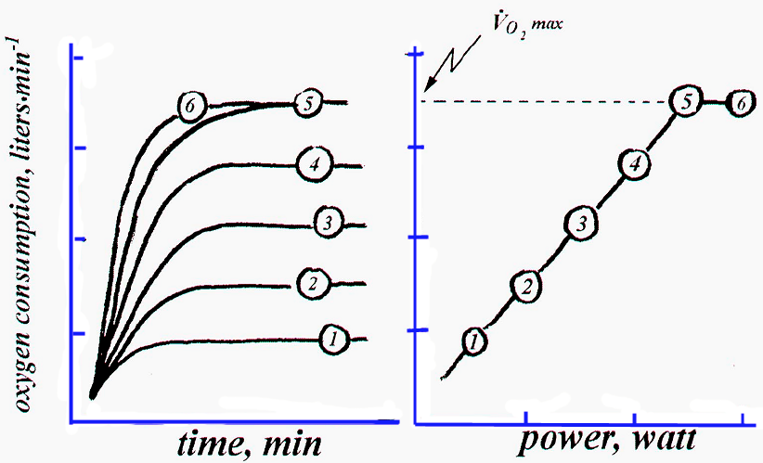
- If you have a greater work/unit time (power), you consume more O₂
- This occurs until you cannot consume any more oxygen (you have reached your VO₂max )
  - You can continue past VO₂max but you must borrow anaerobic sources and then must pay them back
- Accumulation of anaerobic metabolites (eg. lactic acid) will cause muscle pain, and metabolic academia. This causes you to stop exercising
- Therefore, you can’t reach the ideal situation of VO₂max but you can work at ~80% to be safely below the lactic threshold (or anaerobic threshold)

Athletes and VO _{2max}:
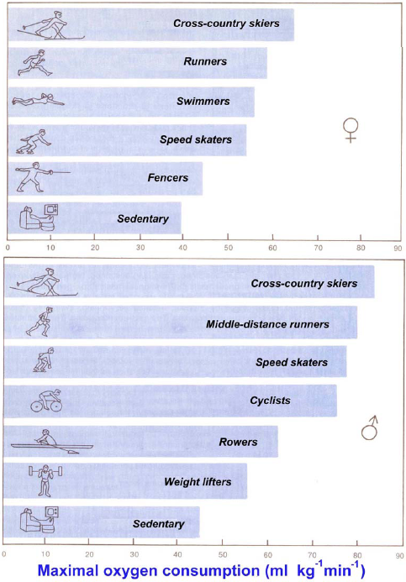
- If you have a higher VO₂max, you can perform better because your anaerobic threshold is increased
- All athletes have a high VO₂max but it differs depending on the athlete’s discipline
  - In the graph, the x-axis represents oxygen consumption per unit weight. As you can see, males have a higher consumption than females and certain disciplines require a higher VO₂max than others
- Sedentary individuals have a VO₂max of ~40 mL/kg/min

Why is there a difference between disciplines?
- We have to pay attention to O₂ consumption in absolute terms (mL/min) versus O₂ consumption in specific terms (mL/kg/min)
- For example, an elephant has a large VO₂max in absolute terms and can pull enormous external loads. On the other hand, the elephant can’t climb a tree because he has to work against himself
- We want to have a higher specific VO₂max because in most sports we do work against ourselves.
  - This is VO₂ per kg; in specific terms NOT absolute terms!
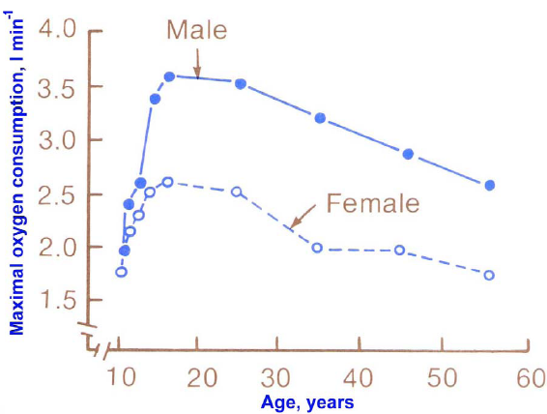
- Maximum O₂ consumption is not a constant. It peaks in the early teens to twenties and then it falls.
- However, the peak does not occur at an age that corresponds to our Olympic records. Many records occur before 20-22 year old range.
  - High VO₂max is a basic component to being a star athlete, but is not the sole ingredient. You must have the specialty to turn cost (calories) into work. This is your efficiency, the ability to transform potential energy (PE) into work.
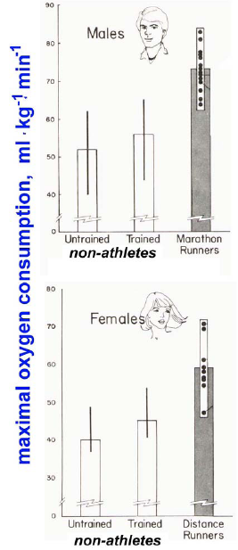
  - The best performances in swimming and gymnastics occur earlier on in life (teens). Marathon records, on the other hand, occur in the late 20s, or early 30s, due to the need for psychological maturity.

- If we train, we can increase our VO₂max by a little (2-3 mL/kg/min), but not much more than that
- The diagram to the right illustrated this increase (middle bar) compared to untrained (first bar) and a runner (last bar)
- You have to be born an athlete to reach that high of a VO₂max, just like you have to be born a seal to be able to dive deep.

IV. EFFICIENCY
- To be a great athlete you must be able to transform energy into work (efficiency)
  - Black people are very good athletes and excel in long distance running because of their high efficiency. They live in high altitudes and train in low altitudes to reach their best VO₂max.
  - However, they do not excel in swimming because their distribution of body fat does not favour their buoyancy.
- In addition, there are other factors that affect efficiency, such as posture and body type.
- In swimming, we want to minimize the cross-section of our body.
  - During fast swims, this keeps the drag small and this is why men can beat women.
  - With longer distances though, the speed is slowed down and the body is oblique. The distribution of body fat is crucial because for long distances you are relying on buoyancy and thus, women have an advantage here. Therefore, they can be competitive against men in absolute terms.

Efficiency = Work/Cost

- Where, Cost = O ₂ consumption (VO ₂max)
  - 1L of O ₂ costs 5 cal
- We must measure work.
  - This can be done using a treadmill, since the external work will be the distance travelled on the treadmill.
  - During this work, if we simultaneously measure the O₂ consumption by collecting it in a spirometer, we can then calculate the efficiency.

How much does it cost to walk?
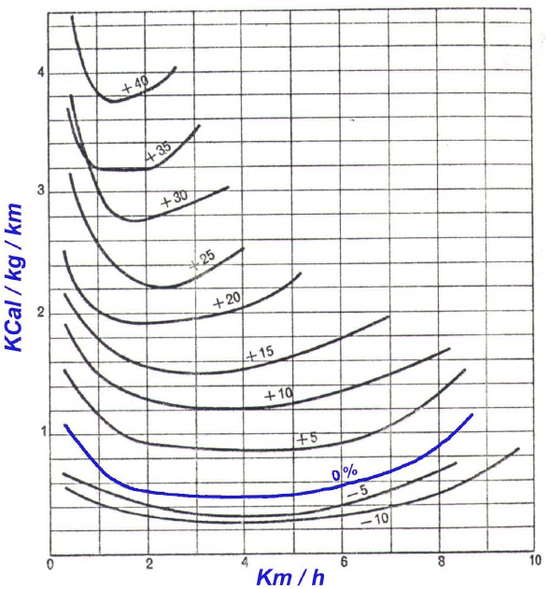
- It does not cost a lot to walk because we have been designed to do this from an early age.
- The graph on the right represents the speed of walking (km/h; x-axis) versus the cost per km of travel (y-axis)
- Cost per unit distance (Cost/km) is the energy cost of transportation

How much energy does it take (per unit weight) to cover a certain distance?
- If you walk fast, you pay more per step but you’re on the course for a shorter period of time (and vice versa). This is why we look at it per unit of travel distance
- On graph, the blue line (0%) is flat
  - The cost of transportation is about constant at ~0.5 kcal/kg/km, between 2-5 km/h
  - This means you can choose the speed that you like in this range, but the cost per distance will be fixed (ie. you will just be walking a longer or shorter amount of time)

Why does the cost go up if I walk too slowly?
- It’s like you’re moving on the spot, spending energy per unit distance but not moving very far, it’s inefficient
- If you walk too fast it’s also inefficient because at around 8-9 km/h you reach a point where it is better to run than walk
- As you move up an incline, the same concepts apply, but the cost goes up. In addition, the range of optimal speeds gets narrower
- In contrast, if you move down a hill, it costs less because gravity is helping you. However, at a point (around -20%) you pay a lot because you have to brake, so you’re spending energy to slow down the 2nd part of your step

What does this all mean?

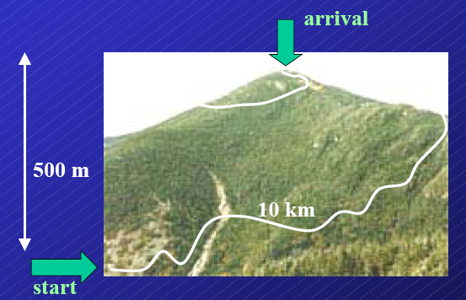

Example: Consider walking up mountain
- If the mountain has a 500m ascent and a 10 km (10 000 m) trail, then it has an average slope of 5% (500/10000 = 5%).

How much are you going to pay to walk up the mountain?
- Choose a speed from the previous graph for a 5% incline. For example, lets use 3.5 km/h at a cost of 0.9 kcal/kg/km
- At 3.5 km/h, it will take about 3 hours to walk up the 10 km trail.
- Therefore, the cost for a 70 kg hiker would be 630 kcal.
0.9 kcal/kg/km x 70 kg x 10 km = 630 kcal

Example: Now consider walking down the mountain
- The slope is now -5% and from the previous graph, the speed is now 4km/h at a cost of 0.3 kcal/kg/km.
- At this speed, it will take about 2.5 hours to walk down the trail (10 km ÷ 4km/hr = 2.5 hr)
- Therefore, our cost to walk down is only 210 kcal.
0.3 kcal/kg/km x 70 kg x 10 km = 210 kcal
- Therefore, the total trip will be 5.5 hours long at a cost of 840 kcal.
- Note that 1 gram of sugar = 5 kcal and 1 gram fat = 9 kcal. So depending on what you eat, this is on average 6-7 kcal/gram.
  - This means that ~150 g of food (equivalent to pizza and a drink) would be enough to provide you with 840 kcal.
(840 kcal ÷ 6 kcal/gram = ~ 150 gram)
- This means that moving around is extremely cheap
  - After this hike, most individuals would go home and eat a larger amount. By doing this, they are actually gaining weight because they did not spend as much walking, as they think they did.
  - To lose weight by walking you have to walk forever because walking is so cheap

Why is walking so cheap?
- This makes sense evolutionarily because we have been using it for a long time
- Walking = transformation of PE (potential energy) into KE (kinetic energy)
- Think of it like rolling an egg; it slows down and speeds up. This is what we do when we walk. The first part of a step is spending energy by lifting the centre of mass. In the second part of a step, PE is recoiled and this propels you.
- Walking is a constant transformation from PE to KE and only when you put your foot down do you overcome friction. Thus, the cost of walking is very small.

Running:
- Running is more expensive, about double the cost of walking on a flat surface but it is still very cheap
  - It is usually 1 kcal/kg/km versus the 0.5 kcal/kg/cal used in walking
- Think of it like a spring that is being squeezed. When you step down the spring is being squeezed and elastic energy is stored. When you step back up, the stored elastic energy is released.
- A kangaroo does this to the extreme, it transforms what is puts down into PE and elastic energy and then transforms it to KE at large level
- This transformation of KE and PE is a trick that allows for a very cheap way of locomotion

V. BREATHING PATTERN
- Breathing is a way to achieve O₂ consumption
- During exercise, we rely on both the inspiratory and the expiratory capacity.
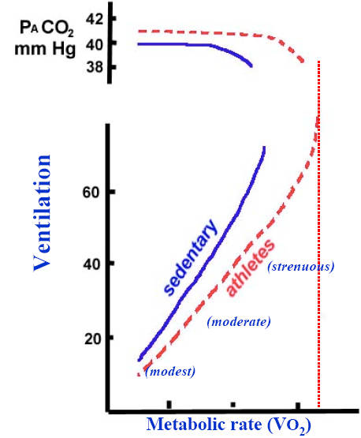
- We contract our expiratory muscles during exercise but we must take into account that these are also our postural muscles.
  - We must integrate expiratory constraints with postural constraints
  - This is why some athletes can’t be as good at other sports because they have to re-organize their efficiency. The respiratory system may be limiting because your breathing pattern may not match up well with a new sport

- The above may imply that breathing is a limiting factor in oxygen consumption (VO₂max), but this is NOT true!
Why not?
- Recall the VO2 – ventilation graph to the right.
- Increased workload leads to and increased metabolic rate and then an increased ventilation. As we can see this relationship is relatively linear, because PCO₂ does not change.
- Eventually, when exercise becomes major, ventilation takes off; you ventilate more than metabolism would require.
- As a result, PCO₂ drops. This is a true situation of hyperventilation because you are hitting the anaerobic threshold
- You can go past your VO₂max (red line) but you must account for aerobic and anaerobic conditions
  - There is a production of lactic acid through anaerobic respiration which stimulates breathing
- Ventilation is no longer matching VO₂ but is also being stimulated by anaerobic sources

Why can we say from this diagram that ventilation is not the limiting factor?
- The curve shows a concavity toward the y-axis (not the x-axis)
- This means that when you reach VO₂max ventilation is not at its maximum
- Ventilation can continue, so you can’t say it is a limiting factor for VO₂; if ventilation stops, VO₂ continues to increase
- It is cardiac output that limits VO₂ max and not respiration
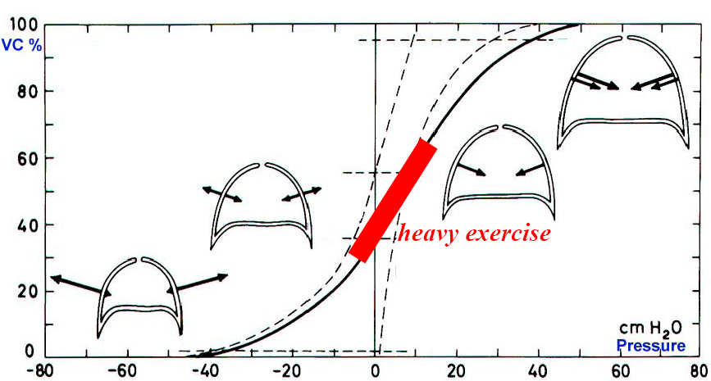
Why is respiration not the limiting factor?
- The graph the right is a P-V curve
- During exercise, like at rest, we are still on the linear portion of the curve. Compliance is about the same at rest and during exercise
- During exercise, though, we are contracting the expiratory muscles because we are below FRC
- The breathing rate will now go up and there is an increase in flow, which is no longer laminar. In addition, the cost related to resistance goes up enormously
- Airway resistance eventually goes up as well, because as you increase flow, pressure related to flow goes up by a square. Recall this is because flow is no longer laminar but follows the turbulent flow equation.
- Effective resistance also goes up during exercise
- There can complications with this, the main one being smoking
  - Smoking causes a large increase in airway resistance

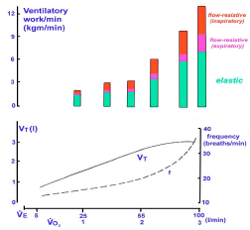
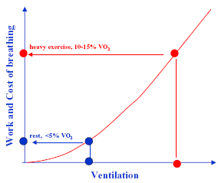

PHGY 312 – Lecture 36 April 11, 2007
Writer: Queenie Chow Dr. Mortola

Concepts Covered in the Last Lecture
- Exercise respiration.
- Energy sources (e.g. ATP depleted quite quickly).
- Oxygen debt (need some time to recruit O₂).
- Maximal oxygen uptake
  - Age and gender dependent.
  - To some extent, training dependent.
- Energy cost of transportation (Cal / kg / km).
- Kinetic and potential energy transformation
  - The trick to making walking so cheap.
- VO₂- V_{E} relationship during exercise.
- Pulmonary ventilation and breathing pattern in exercise (pattern changes in exercise usually highly predictable).
- Respiratory compliance and resistance in exercise (resistance goes up during exercise, as flow increases, turbulent flow increases, and pressure is proportionate to the square of the rate of flow).
- The work and cost of breathing
  - In resting conditions, the cost of breathing is relatively low.
  - During exercise, the cost of breathing can increase up to 10-15% of VO₂ max (at sea level).

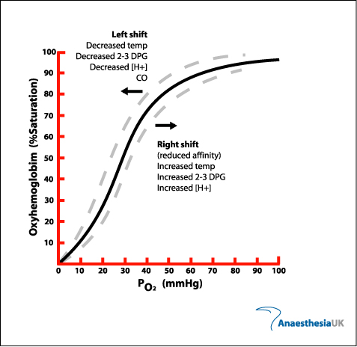
Review Questions

Note: Correct answers are in bold.

- During moderate muscle exercise, the oxygen unloading at the peripheral tissues is increased because:
  - An increase in muscle temperature and decrease in O₂ binding affinity
    - TRUE. Temperature shifts the oxygen dissociation curve (ODC) to the right.
  - Lactic acid decreases O₂ affinity (or P₅₀)
    - FALSE. H⁺ does shift ODC to the right (decreases affinity), but during moderate exercise, lactic acid is not really produced.
Oxygen Dissociation Curve
  - Hypocapnia due to exercise-hyperventilation
    - FALSE. Hypocapnia moves the Hb oxygen dissociation curve to the left, not right.
    - Recall that moving the ODC to the right means decreased O₂ binding affinity – favors the unloading of oxygen; this is what we want at the tissue level.
Note: P₅₀ is the partial pressure of O₂ at which there is 50% O₂ saturation of Hb. If the curve is shifted to the right, P₅₀ increases (low affinity), and if the curve is shifted to the left, P₅₀ decreases (high affinity).

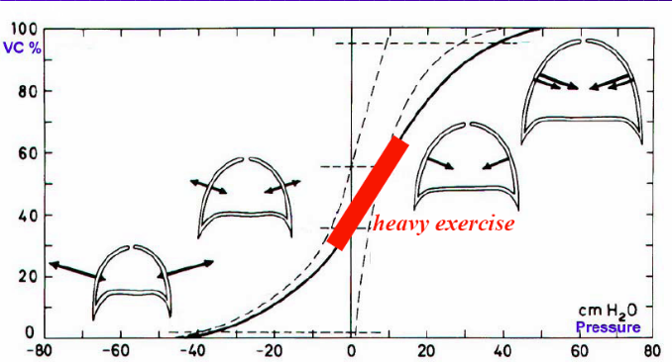
- During strenuous aerobic muscle exercise:
  - Hypocapnia is likely to occur
    - TRUE. It depends on the type of exercise.
    - During moderate exercise, PCO₂ remains relatively the same.
    - It is only during maximal exercise that PCO₂ decreases because ventilation is under the drive of metabolism and glycolysis.
    - Metabolism and ventilation go out of proportion because in extreme exercise glycolysis, the processing of lactic acid, requires O₂, therefore hyperventilation occurs and PCO₂ drops.
  - The expiratory muscles are active
  - Lung compliance is decreased.
    - FALSE. Even during heavy exercise, we remain on the linear portion of the pressure-volume curve therefore compliance is constant.
  - Airway resistance is increased
    - Airway resistance increases because of increased flow.

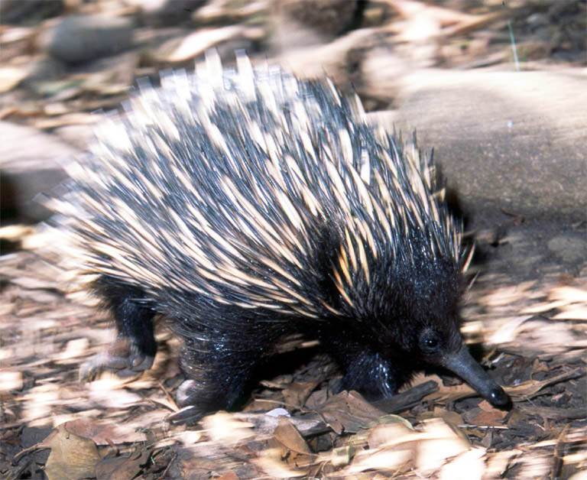
NEONATAL RESPIRATION

- Babies should not be regarded as a miniature version of an adult human being.

Fetuses
- Grow in a fluid-filled environment.
- The echidna is an Australian mammal. It is strange because it doesn’t produce live fetuses, but eggs. There aren’t many mammals that do this.
- The embryo is floating in an amniotic sac in the egg. This means that there is no direct access to air.
- We study their eggs in comparison with the human fetus, both fetuses grow in a fluid-filled environment
- In the womb, the human fetus is connected to the mother through the umbilical cord, which is connected to the diffusing organ (placenta in mammals). In the egg, the diffusing organ is the well-vascularized membrane just under the shell and the shell itself.
- Amniotic sac which contains the fetus is filled with fluid. The fetus’s lungs are filled with fluid, and from a respiratory function point of view they are completely useless. Yet a few seconds after birth, the newborn’s lungs start to work.
- At birth, the lungs are still liquid-filled. This liquid is crucial and helps the development of the lungs.
- Fetal respiratory movements (in the womb before birth) are highly intermittent. They are not for gas exchange purposes (as there is no gas to exchange), and can be thought to be exercises of the respiratory muscles, but it also helps keep the fluid inside the lungs.
- There are periods where there are no respiratory movements (especially near the end of gestation), and during these times, the larynx closes completely and the fluid cannot come out.
- However, some of the fluid in the lungs does come out. Therefore the amniotic fluid can be sampled for surfactant. If surfactant is detected, the fetus is most likely mature and ready to come out.
Birth
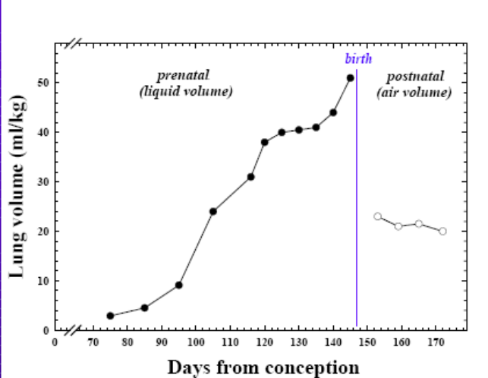
- At birth, the lungs of the fetus are filled with fluid and are quite stretched. This fluid must be eliminated.
- Since the newborn is suddenly deprived of oxygen coming from the placenta and goes from diffusion to pulmonary ventilation in a matter of minutes or seconds after birth, the priority is the establishment of ventilation, or the establishment of FRC.
- The establishment of FRC: in the first breath of the newborn, the amount expired and is less than the amount inspired (trace on right). This is a very small amount, so it takes from hours to days to establish the full FRC.
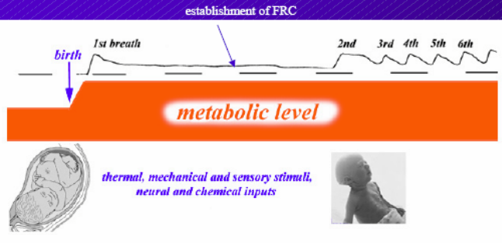
- What makes breathing continuous and regular as opposed to the intermittent fetal respiratory movements is still a mystery.
  - At birth there may be various thermal, mechanical, and sensory stimuli, and these combined increase metabolic rate.
  - Metabolic rate is probably the key stimulus for ventilation.

In summary, three things must be done quickly at birth:
- The establishment of FRC
- The elimination of fluid from the lungs
- Continuous breathing

Birth in Water
- Aquatic species, e.g. dolphins and whales, are born tail-first, or else they would drown in water at birth.
- The mother helps the baby to get to the surface of the water to establish FRC for its first breath; also to get enough air so that buoyancy is no longer a problem.

Lungs
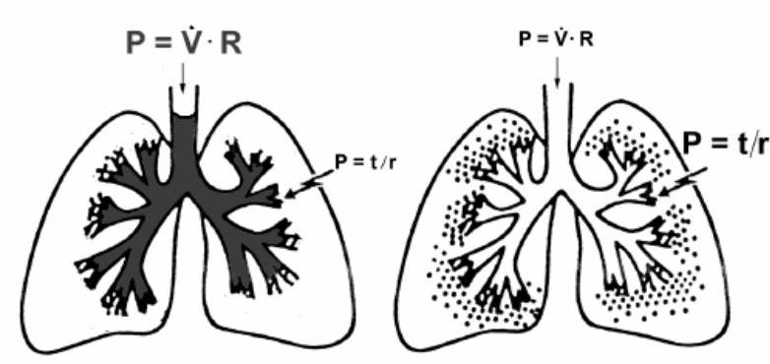
- Figure to the right is of two lungs, one at birth and one a few days after birth.
- At birth, the lungs are filled with water. The volume and compliance do not change much whether the lungs are water-filled or air filled, but what changes is the pressure related to resistance and the pressure related to surface forces.
- In a water filled lung, the majority of work (pressure) required is related to resistance (P=V*R), while recoil pressure due to surface tension (P=t/r) is low.
  - P=V*R is great because R is increased by the increased viscosity of the water. Recall Poiseuille’s law P=Q*R, where R = (8ηL) / (πr⁴), and η = viscosity, L and r = length and radius of airway respectively.
  - Recoil P=t/r, where t = surface tension, and r = radius of curvature of alveoli. Recoil pressure is small because r of alveoli is increased by the distension due to water in the lungs.
- As water moves out from the lungs, the work required to move the column of water becomes small, and the majority of the work goes into overcoming recoil pressure. This is the case after a few breaths, and in the case of adults.
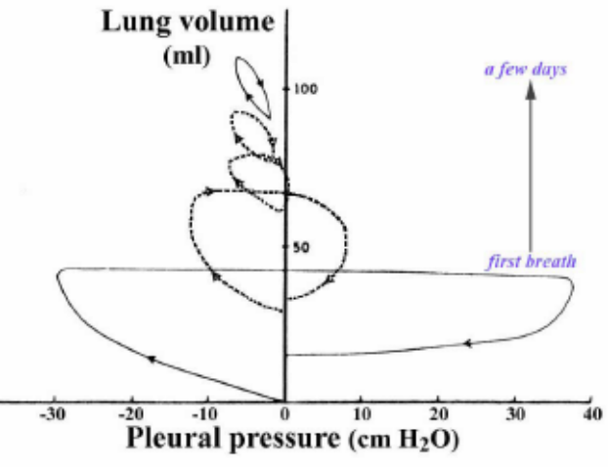
Recording of the First Breaths of a Newborn
- In the first breath, a very negative pressure is recorded.
- The great positive pleural pressure (means a great positive airway pressure) helps to push the fluid of the lungs outside to be picked up by the lymphatic system.
- The amount exhaled is less the amount inhaled. This is the establishment of FRC as seen in the previous recording.
- As hours and days go by, the pleural pressure-volume loop is smaller and resembles that of the adult. The pleural pressure is only slightly negative.
- The area under the curve is work (W=P*V). This shows that the first breath requires much greater work than in subsequent breaths under stabilized condition.
- If the baby did not have surfactant, breathing would be like the first loop all the time. The baby can begin breathing, but the baby’s respiratory muscles (especially premature babies) are not very strong and will not be able to sustain this type of breathing for long periods of time.
  - Even if the muscles could do the work, half the lung would remain deflated and this would have detrimental effects on the ventilation perfusion ratio.

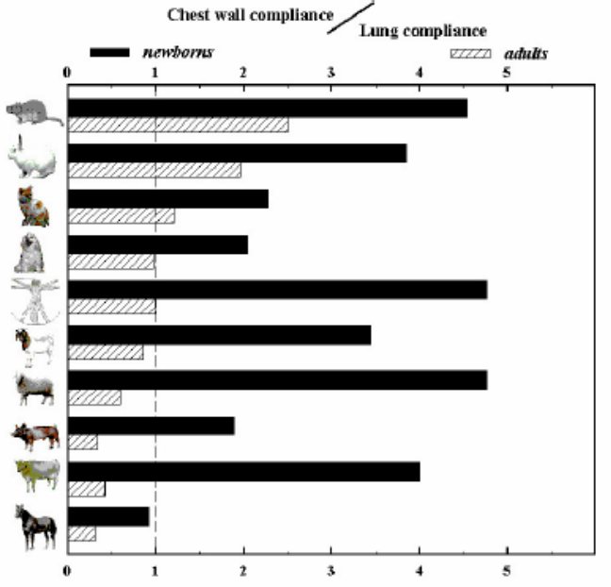
Newborns Have a HIGH (Chest Wall Compliance / Lung Compliance) Ratio
- At birth, one reason why the delivery through the narrow birth canal is possible is because the baby is very compliant. High chest wall compliance is a necessity at birth (young tissues are very watery).
  - Increased compliance means the chest wall is not pulling out as much.
  - Increased compliance means decreased resting volume (V_{R}).
  - Newborns must establish FRC right away and yet this is not favourable mechanically because of the high compliance.
- In all species, newborns have a higher compliance ratio than adults.
  - The ratio in adult humans is 1, compared with the newborn’s ratio of 4.

Problems with high (Chest Wall Compliance / Lung Compliance) ratio:
- Inspiration. If the chest wall is too floppy, then when the diaphragm contracts, the rib cage caves in. This is known as the paradoxical movement of the rib cage (as seen previously in tetraplegic patients).
  - This movement can be easily observed in babies, especially during REM sleep when the intercostal muscles are further inhibited.
  - This means that breathing due to diaphragmatic contraction is not as efficient as in adults, as the pressure exerted meant to bring air in simply sucks the thorax in.
  - Fortunately, babies do not exercise so what they breathe is enough.
- Expiration. High recoil of the lung relative to the chest means that FRC is low. Low FRC is undesirable as discussed in previous lectures (to minimize oxidation of alveolar gases, to decrease the work of breathing, etc). How does the newborn overcome this problem?
  - Closing of the larynx. As mentioned before, this was important in fetal life to preserve pulmonary fluid.
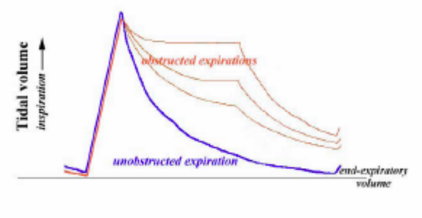
Figure
- Blue line (“unobstructed expiration”) is the expected spirometric recording for a subject breathing with a completely opened larynx.
- Volume declines in expiration along an exponential curve.
- Red lines (“obstructed expiration”) show the spirometric recording from newborn mammals, expiration is almost completely obstructed due to the closing of larynx, maintaining an elevated mean lung volume.
    - Why is this useful to the baby? If the baby allows the expiration to go down more slowly, the next breath taken can be before the lung reaches resting volume.
    - This is called the dynamic elevation of FRC.
    - Therefore, even if mechanically the FRC is supposed to be low, by playing with the breathing patterns, FRC is dynamically elevated.
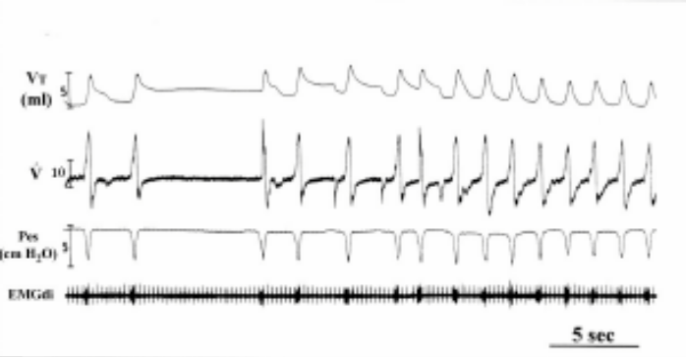
Muscles in the Larynx
- Are responsible for the interruption of expiration.
- Why is this called closing of the larynx instead of breath-holding?

- Top figure: recording from a newborn puppy.
  - Notice in the V_{T} trace that expiration is interrupted.
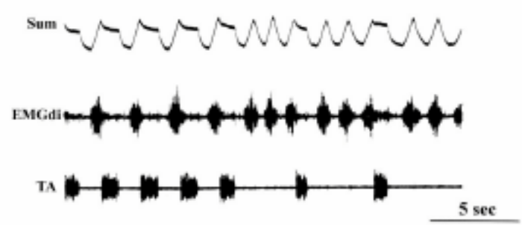
  - Look at the EMGdi trace, the EMG recording of the diaphragm. (Ignore in-between spikes, those are a result of heart contractions) The bursts indicate EMG activity of the diaphragm, they occur during inspiration, but are absent in expiration, hence the puppy is not breath-holding.
- Middle figure: similar recording from a newborn.
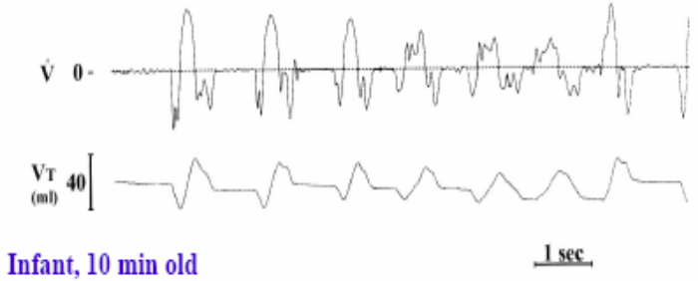
  - Occlusion of the larynx can be observed in the TA trace (TA = thyroarytenoid muscle, an abductor muscle of the vocal cords).
  - During inspiration, the diaphragm (EMGdi) is active, but expiration is blocked by activity of the TA muscle closing the vocal cords. TA muscles slow down expiration.
- Bottom figure: similar recording from a newborn 10-minute-old infant at the Royal Victoria Hospital.
    - Shows that expiration is interrupted.
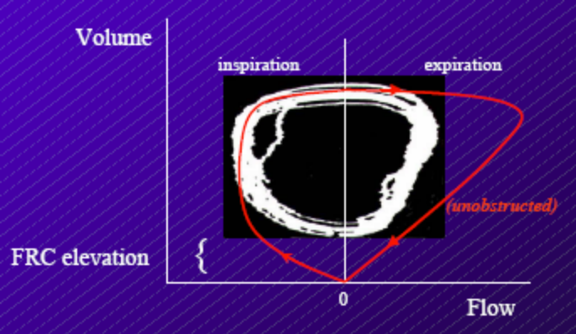
Volume-Flow Curve
- The red trace (“unobstructed”) shows the expected volume-flow change in inspiration and expiration where the larynx is not closed. The trace in the background shows what actually happens in a newborn (trace of many breaths).
  - Inspiration more or less follows the expected curve.
  - Expiration flow is substantially less than expected. Closing of larynx provides extra resistance.
  - Dynamic elevation of FRC is observed because, as explained, the next breath occurs before resting volume is reached. By narrowing the vocal fold (i.e. closing the larynx) expiration is prolonged and this makes up for the fact that the rib cage goes in during diaphragmatic contraction.
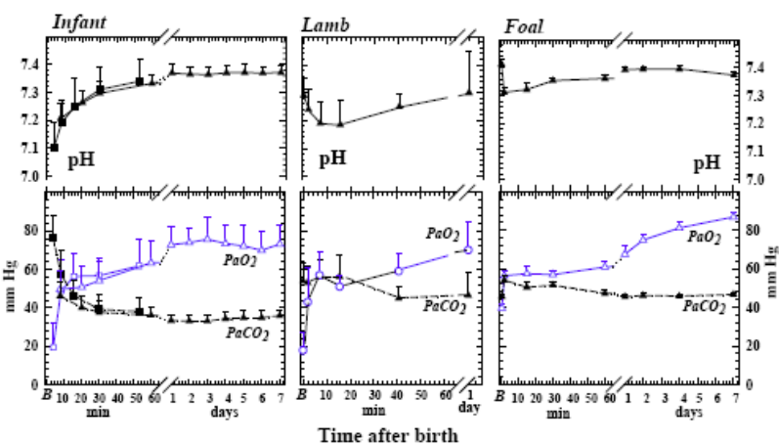
PO₂ in Infants Rise Following Birth
- The graphs show measurements taken from several newborns from different species.
- PO₂ rises rapidly at birth.
- After about 1 week, an infant’s PO₂ has risen to about 80 mmHg, close to the adult’s PO₂ of 100 mmHg. Although, to reach the normal adult PO₂ value would take much longer than that.
- Pulmonary circulation in the baby must be readjusted from the in utero state where very little blood goes to the lungs. This involves closing of the shunt and immediate opening of the pulmonary vessels. These changes would not occur if PO₂ did not rise.
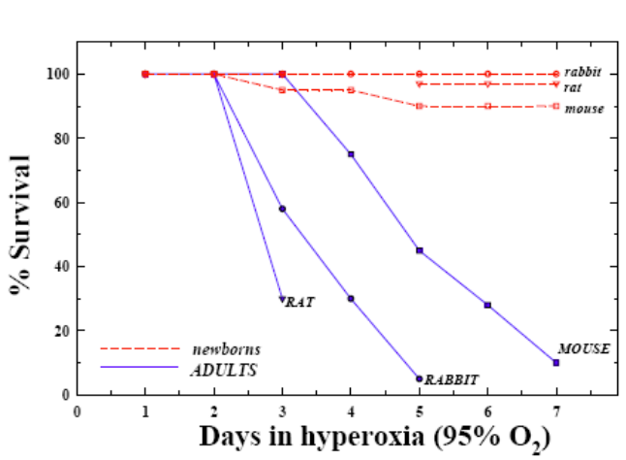
- Because of the relative hyperoxia conditions the newborn faces compared to in utero, they are better-protected from the hazards of an hyperoxic environment than adult organisms

Graph:
- Newborns (red dashed lines) and adults (solid blue lines) were put in a hyperoxic environment with almost pure oxygen.
- More newborns survive in exposure to hyperoxia.
- The reason: newborns contain various enzymes in their lungs which counteract the effects of a hyperoxic environment.
- Glutathione peroxidase (GP), superoxide dismutase (SOD), and catalase (CAT) are present in the baby’s lung even before birth in anticipation of a period of hyperoxia.
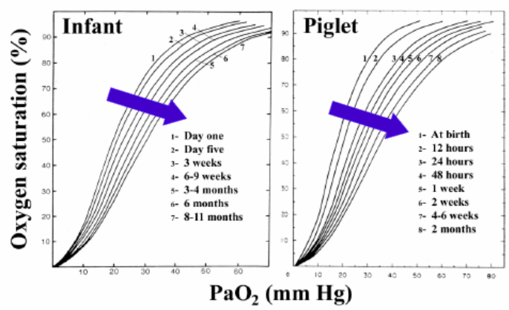
Changes in Hemoglobin
- The ODC shifts to the right after birth.
- This is NOT due to changes in PO₂ after birth. PO₂ does not shift the graph like temperature and pH do.
- This is due to a change in hemoglobin (Hb). The fetal Hb is no longer expressed.
  - Fetal Hb has a higher affinity for oxygen as the fetus is in a low O₂ environment.
  - Fetal Hb is exchanged in favour of the adult Hb.
  - This shifts the ODC to the right with time.

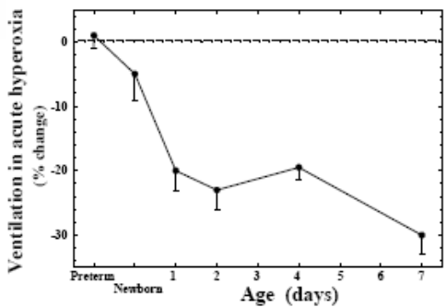
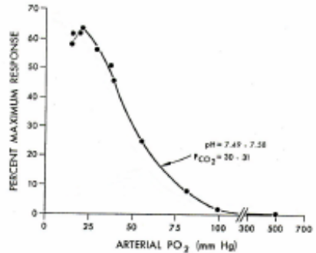
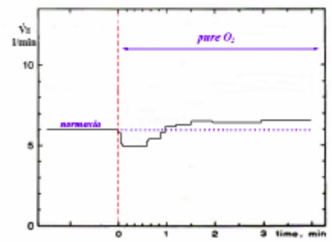
Hyperoxia

Left and Middle Graphs
- Recall that there is tonic activity of the carotid body even at normal PO₂ levels.
- In hyperoxia, the tonic activity would go down and result in decreased ventilation. This drop in ventilation is used as an index of the tonic activity of the carotid body.

Right Graph
- If oxygen is given to a newborn, the % change in ventilation due to hyperoxia is zero, i.e. newborn babies do not respond to hyperoxia.
- This is because the carotid bodies are already flooded with oxygen; in other words, newborns are already in a hyperoxic situation.

Hypoxia
- Newborns survive better in low oxygen environments because:
  - They are already in a hyperoxic state.
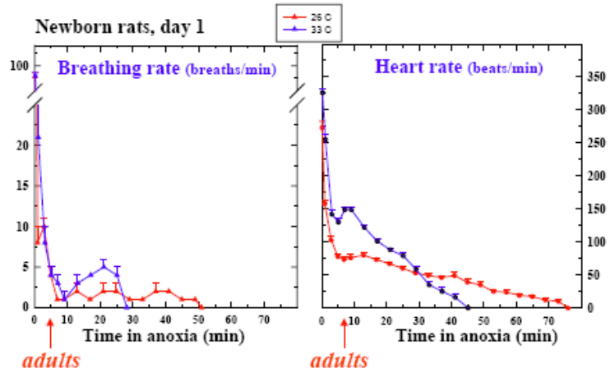
  - They are able to lower their metabolism in response to hypoxia, a strategy lost in adults; adults respond by increasing ventilation.

Graphs:
- Experiment done a long time ago in which newborn and adult organisms were exposed to anoxia (just nitrogen).
- The last breath taken and the last heart contraction in adults were, respectively, about 5 minutes and 7 minutes following deprivation of oxygen.
- The last breath taken and the last heart contraction in newborns were, respectively, about 30 minutes and 45 minutes following deprivation of oxygen, at 33°C. At colder temperatures, the times can be even longer as metabolic rate is lower.
  - This is why infants that have been reported to have dropped in icy cold water and have survived even if they were rescued after many minutes have passed.

One little problem with the strategy of dropping metabolic rate in response to hypoxia:
- Among many stimuli for ventilatory drive, metabolism is a main stimulus.
- If the newborn drops metabolism in response to hypoxia, it also drops its drive to breathe.
- Hypoxia can stimulate the carotid bodies, and this is a positive drive on ventilation.
- Hypometabolism can be a greater inhibition on ventilation if other positive stimuli (increased chemosensitivity) are taken away.
- This is dangerous because it takes only a little more inhibition of the ventilation to completely stop breathing irreversibly. This can cause sudden infant death syndrome (SIDS), a.k.a. crib death. SIDS is rare, however, and occurs in less than 1 death in 1000 infants.

Well, sorry for ending on that note, but that’s the end of the course. Good luck on exams!

